# ROC Tables Explained

## Overview

Reduced Order Control (ROC) tables allow coordinated movement of multiple joints in the Modular Prosthetic Limb (MPL)

## ROC Table theory of operation

ROC tables are used to define a trajectory over a continuous normalized motion range that begins with 0 and ends with 1. A series of discrete waypoints along that trajectory define specific joint angles that the limb should conform to at that phase of the ROC. Joint angles between waypoints are linearly interpolated based on the current position relative to the nearest waypoints.

## ROC Table xml example:

The example below shows the actual xml implementation of a ROC table for an example grasp. In this case, a lateral grasp (also called Key Grasp) requires the fingers to form a platform and then actuate the thumb to close and stably react against the lateral face of the index finger. In order for this grasp to be effective, the finger platform should be formed first, and only then will the thumb begin to move.

<?xml version="1.0" encoding="utf-8"?>

<roc_tables>

<table>

<id>15</id>

<name>Lateral</name>

<joints>8,9,10,11,12,13,14,15,16,17,18,19,20,21,22,23,24,25,26,27</joints>

<waypoint index="0.000">

<angles>-0.100000,0.000000,0.384000,0.314200,0.000000, 0.000000, 0.384000,0.314200,0.000000,0.000000,0.384000,0.314200,0.200000,0.000000,0.384000,0.314200, 0.000000,0.400000,0.261800,0.100000</angles>

</waypoint>

<waypoint index="0.600"> <angles>0.000000,1.193805,1.200787,1.200787,0.000000,1.570796,1.000074,1.000074,-0.020944,3.141593,2.115339,0.314159,-0.020944,1.000074,2.953097,3.141593, 0.000000,0.399680,0.261799,0.099484</angles>

</waypoint>

<waypoint index="1.000"> <angles>0.000000,1.193805,1.200787,1.200787,0.000000,1.570796,1.000074,1.000074,-0.020944,3.141593,2.115339,0.314159,-0.020944,1.000074,2.953097,3.141593, 0.499164,0.499164,1.200787,0.099484</angles>

</waypoint>

</table>

</roc_tables>

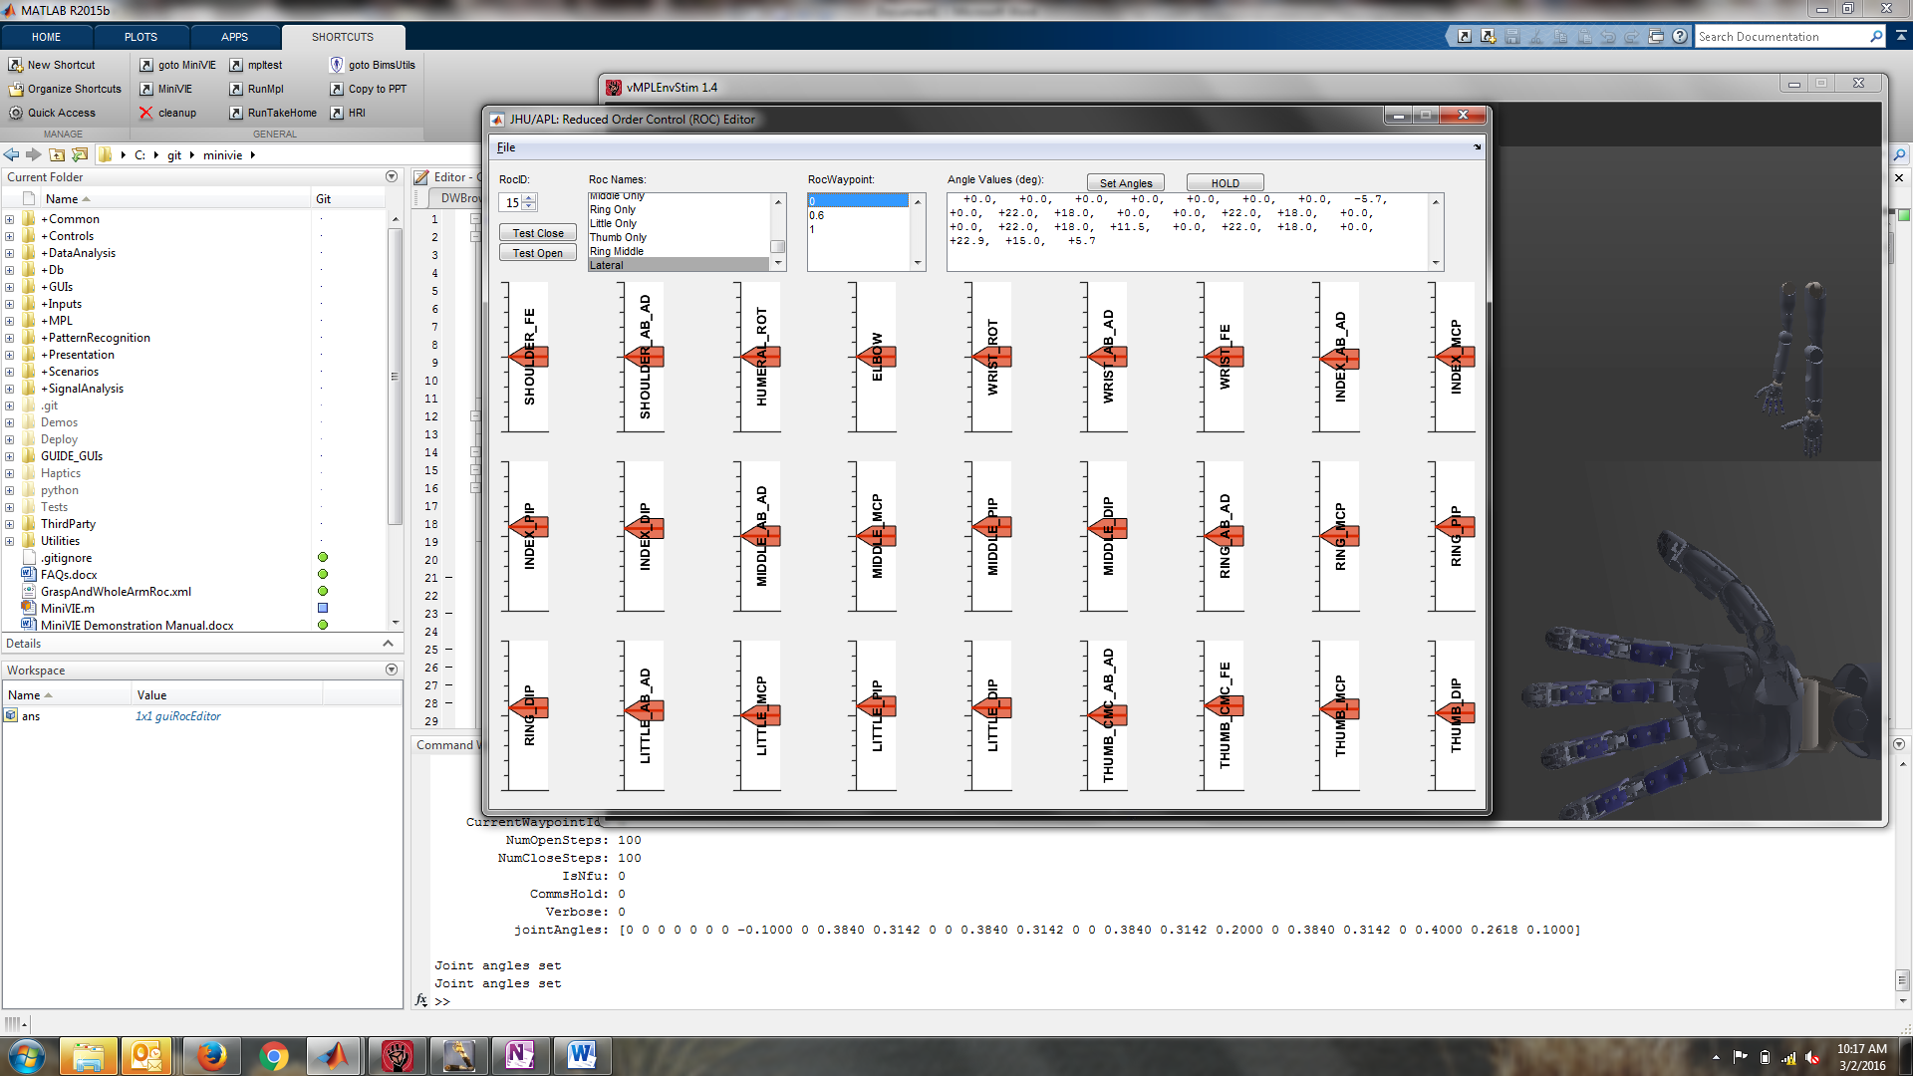

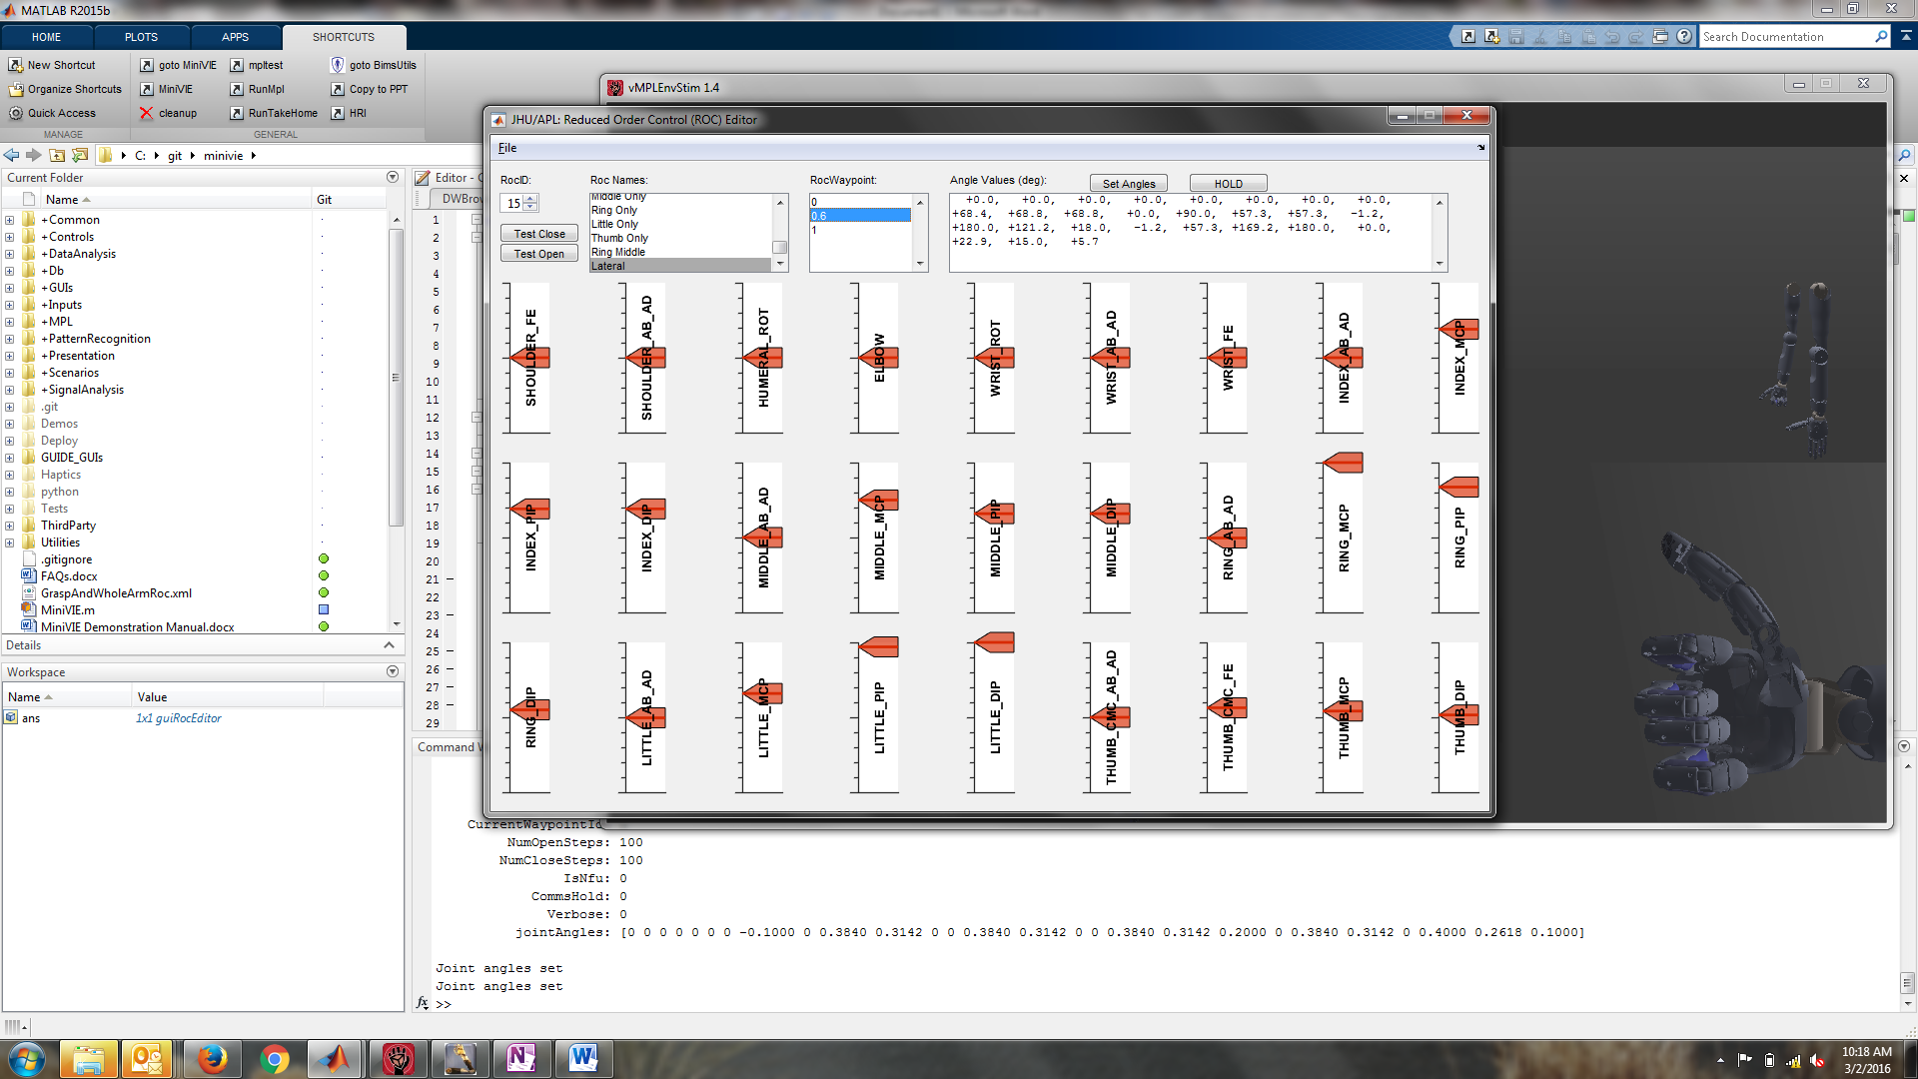

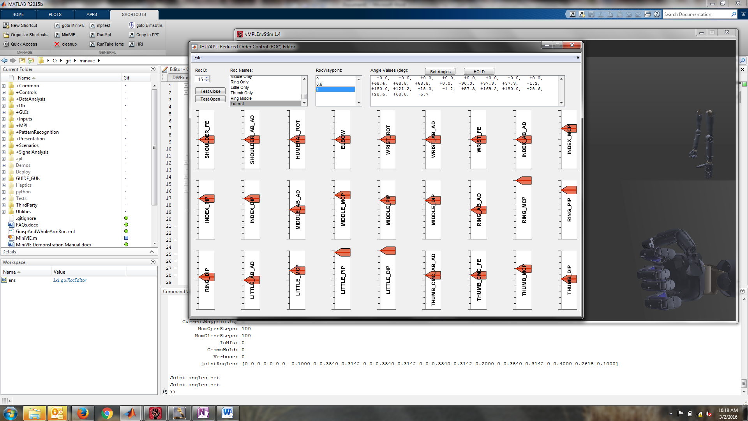

When the current motion position is [0.0], then the hand will be exactly in the open position defined by the waypoint with index=0.0 in the table. As the hand begins to close, the current motion position increases [0.01] then [0.02] then [0.03] etc (representing 1% closed, 2% closed, 3% closed etc) then the joint angles are looked up and interpolated accordingly.

In the example provided at motion position [0.3] the hand will be at the midpoint between waypoints [0.0] and [0.6]. The Index_MCP joint will be commanded to 0.5969025 as this is halfway between 0.00000 and 1.193805 for joint ID=9.

In MATLAB, getting desired joint angles can be computed using the interpolation command:

mplAngles(roc.joints) = interp1(roc.waypoint,roc.angles,rocValue);

where mplAngles is a [1x27] array of joint angles, roc.joints is an array of joints in the ROC table, roc.waypoint is an array of waypoint values, roc.angles is a [nWayPoints x nRocJoints] matrix of waypoints, and rocValue is a scalar value for the current motion position ranging from 0 to 1;

# References

## Joint Id Enumeration

SHOULDER_FE = 1; % + Flexion

SHOULDER_AB_AD = 2; % + Adduction (toward midline)

HUMERAL_ROT = 3; % + Internal (Medial) Rotation

ELBOW = 4; % + Flexion

WRIST_ROT = 5; % + Supination

WRIST_AB_AD = 6; % + Ulnar Deviation

WRIST_FE = 7; % + Flexion

INDEX_AB_AD = 8;

INDEX_MCP = 9;

INDEX_PIP = 10;

INDEX_DIP = 11;

MIDDLE_AB_AD = 12;

MIDDLE_MCP = 13;

MIDDLE_PIP = 14;

MIDDLE_DIP = 15;

RING_AB_AD = 16;

RING_MCP = 17;

RING_PIP = 18;

RING_DIP = 19;

LITTLE_AB_AD = 20;

LITTLE_MCP = 21;

LITTLE_PIP = 22;

LITTLE_DIP = 23;

THUMB_CMC_AB_AD = 24;

THUMB_CMC_FE = 25;

THUMB_MCP = 26;

THUMB_DIP = 27;

## Code Samples

Git repository: <https://bitbucket.org/rarmiger/minivie>

+MPL\RocTable.m

+GUIs.guiRocEditor.m

+MPL\EnumArm.m

+MPL\TEST_VulcanX.m

+MPL\MudCommandEncoder.m